Diamond House DH1.68,
Harwell Oxford Campus,
Didcot, OX11 0DE.
01235 778241
chairman@harbug.org.uk
1st October 2015

North East Didcot Outline Planning Application – P15/S2902/O

Dear Ms Scotting,

Harwell Bicycle Users Group (HarBUG) has commented previously on the Scoping report for North East Didcot and we would like to comment further on the outline planning application.

We are objecting to the outline planning application as we believe that there are aspects of the application, with relation to cycle infrastructure, that need to be revised and detailed further.

HarBUG welcomes the inclusion of a cycle network in the development and the logical layout of the routes. We also welcome the commitment to upgrade the crossing points across the A4130 Northern Distributor Road.
Didcot North East has the opportunity to become a development where residents and visitors have a real choice on how they travel, with cycling becoming a credible alternative to motorised vehicles. Cycling could be the fastest transport mode to get from Didcot North East to the town centre and Didcot Parkway.
This requires careful planning and timing for the delivery of infrastructure. The outline planning application provides a good base to work from.

We would like the developers to include well designed cycle infrastructure, unfortunately in most cases, money is wasted on paths where it is more convenient, quicker and sometimes safer to stay on the main carriageway. We would like to see the philosophy of the Dutch and Danish used in the design and the principles of the Space for Cycling Campaign.

In general:

- Cycle paths should be continuous, cyclists should not be expected to give way at side roads. Please see photo overleaf for an example of a junction design, in Oxfordshire, where cyclists retain priority over vehicles on the side roads.

- Where possible, cyclists and pedestrians should be segregated. Shared use paths are not popular with pedestrians or cyclists.

- No ‘Cyclists Dismount’ or ‘End of Route’ signs.
1 Junction with Cycle Priority in Oxford.
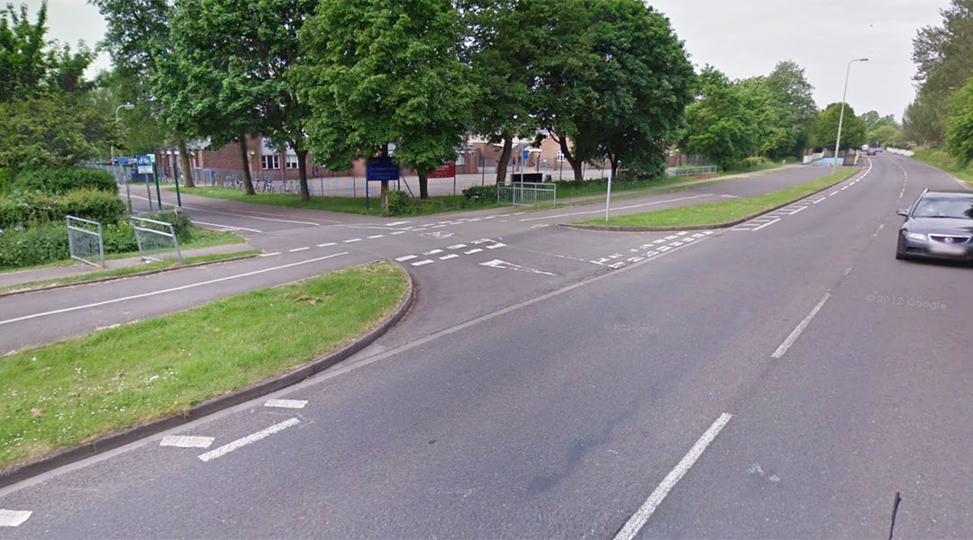

Issues in particular for Didcot North East:

- Delivery of Cycling Infrastructure.
Cycling infrastructure should be built at the earliest opportunity to allow residents to cycle as soon as they move in and be able to cycle out of the development to the town, station, secondary schools etc. We should learn lessons from Great Western Park where residents were left with driving cars as the only practical transport choice.
Changes to transport habits/modes are most likely to happen when other change is happening. Moving house or job are the best chances to get people to change how they move around. This is why the timing of delivery of cycling infrastructure is critical.

- Signage for Cycling (Science Vale Cycle Network)
Signing of cycle routes is important. The signage should be integrated with the Science Vale Cycle network and conform to the standard sign format for the Science Vale.

- Informing New Residents of Their Choices.
New residents should know about their transport alternatives. A leaflet should be delivered to each new house, as the resident moves in, explaining cycle routes available, how to get cycling and the benefits of choosing cycling.
In addition existing residents of Didcot should also be made aware of the new cycle routes, especially when the new leisure centre opens.

- Hopkins Bridge Underpass.
Hopkins Bridge is the most important crossing point on the Northern Distributor Road (A4130) for cyclists and pedestrians. It would provide a continuous, straight, direct link for pedestrians and cyclists from the development to the town centre and Didcot Parkway. Many of the proposed cycle routes feed into this point.
The Northern Distributor Road (A4130) will always be a barrier to integrating the development to existing Didcot, even with speed restrictions it will be a very busy road.
At Hopkins Bridge an underpass should be built to provide a traffic free link into the Ladygrove. A well designed underpass should be able to mitigate the anti-social behaviours associated with some underpasses. With an underpass, cycling to the town centre or station could be quicker than driving. This ‘cycling advantage’ could have a significant impact on the level of congestion on the roads caused by the development.

- Sustrans Route 5 Tunnel Improvements.
The cycle path under the Ladygrove Bridge is also an important crossing point. In the outline planning application this has been identified. The path through the tunnel needs to widened and re-surfaced, to avoid affecting the flow of water in Moor Ditch the extended path could be a mezzanine platform over the water. Accessibility to the tunnel needs to be improved and lighting needs to be installed. The path through the tunnel should be designed and installed to minimise the chance of the path flooding.

- Upgrade of Sustrans Route 5.
The Sustrans route 5 needs to widened and resurfaced from the Ladygrove Bridge to the junction with Appleford Road. This will be needed with the increase in cycle and pedestrian traffic on the path.

- Appleford Shared Use Path.
A cycle / pedestrian path along the B4016 from the Sustrans cycle path 5 junction into Appleford village should be built as there will be a demand for cycle and pedestrian traffic along this road.

- A4130 Northern Distributor Road Changes.
We don’t believe that the proposed speed limit will make much change to the A4130 other than cause more congestion with the extra traffic from the development. The road will be an even busier main road, especially with proposed improvements e.g. the Science Bridge and extension to Wallingford Road. Speeding will be a problem with neither the Police nor Council having the budgets to enforce it.
We believe the resources should be focussed on the Hopkins Bridge Underpass and Ladygrove Bridge Tunnel to provide routes without having to cross the road.

Yours sincerely
Kevin Wilkinson HarBUG Chairman www.harbug.org.uk

