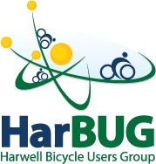

Please could you post the text below on your intranet page to promote the Campus Cycle to Work Day.
Thank you
HarBUG

HarBUG, the Campus bicycle users group, is running a Spring Campus Cycle to Work Day on Wednesday 3rd April. If you have thought about cycling to work or starting cycling again after Winter join us join one of our easy paced escorted rides to the Campus. Our rides are suitable for all fitness levels. Just turn up before the departure time detailed below:
- Didcot Parkway, Brompton hire lockers - Depart 07:50
- Wantage, Nelson Pub - Depart 07:45
- Grove, Millbrook Square - Depart 07:30
We are offering a free cyclists breakfast for all Campus staff who cycle to work on the day, sponsored by Ricardo.
Breakfasts are served at the Harwell Pavilion, Thomson Entrance from 07:30 to 09:00. Vegetarian option available.
Please see the HarBUG website for further details: www.harbug.org.uk

